**SMART IRRIGATION SYSTEM DOCUMENTATION**

**OVERVIEW:**

Interface the ESP32 with a moisture sensor, temperature sensor, air humidity sensor, water flow sensor, and solenoid valve. Using the data from these sensors, the ESP32 determines when to open the solenoid valve. The solenoid valve controls the flow of water into the pipes of the drip irrigation system.

The temperature sensor probe and soil moisture sensor probe are to be inserted into the soil to monitor the soil temperature and moisture levels, respectively.

The water flow sensor provides data on the water flow rate, and the humidity sensor measures the humidity of the air. The system opens a solenoid valve to water the plants using a relay. The ESP32 uses Wi-Fi to communicate with the mobile app via cloud.

If the soil is dry, ESP32 then obtains the current time of the day and compares it to the morning and evening irrigation time windows. If the time is within the irrigation time window, the ESP32 will check if the soil temperature is within the ideal range. If the temperature is within the ideal range for maximum water absorption, the ESP32 will open the valve for a fixed duration and water the plants. The ESP32 will then wait for a fixed duration before checking the soil moisture level.

If the soil is dry but the current time is not within the irrigation time windows, the ESP32 will not open the valve. Similarly, if the temperature is not in the ideal range, the ESP32 will not open the valve. If the soil is humid during the moisture check, the ESP32 will keep the valve closed.

**FLOW:**

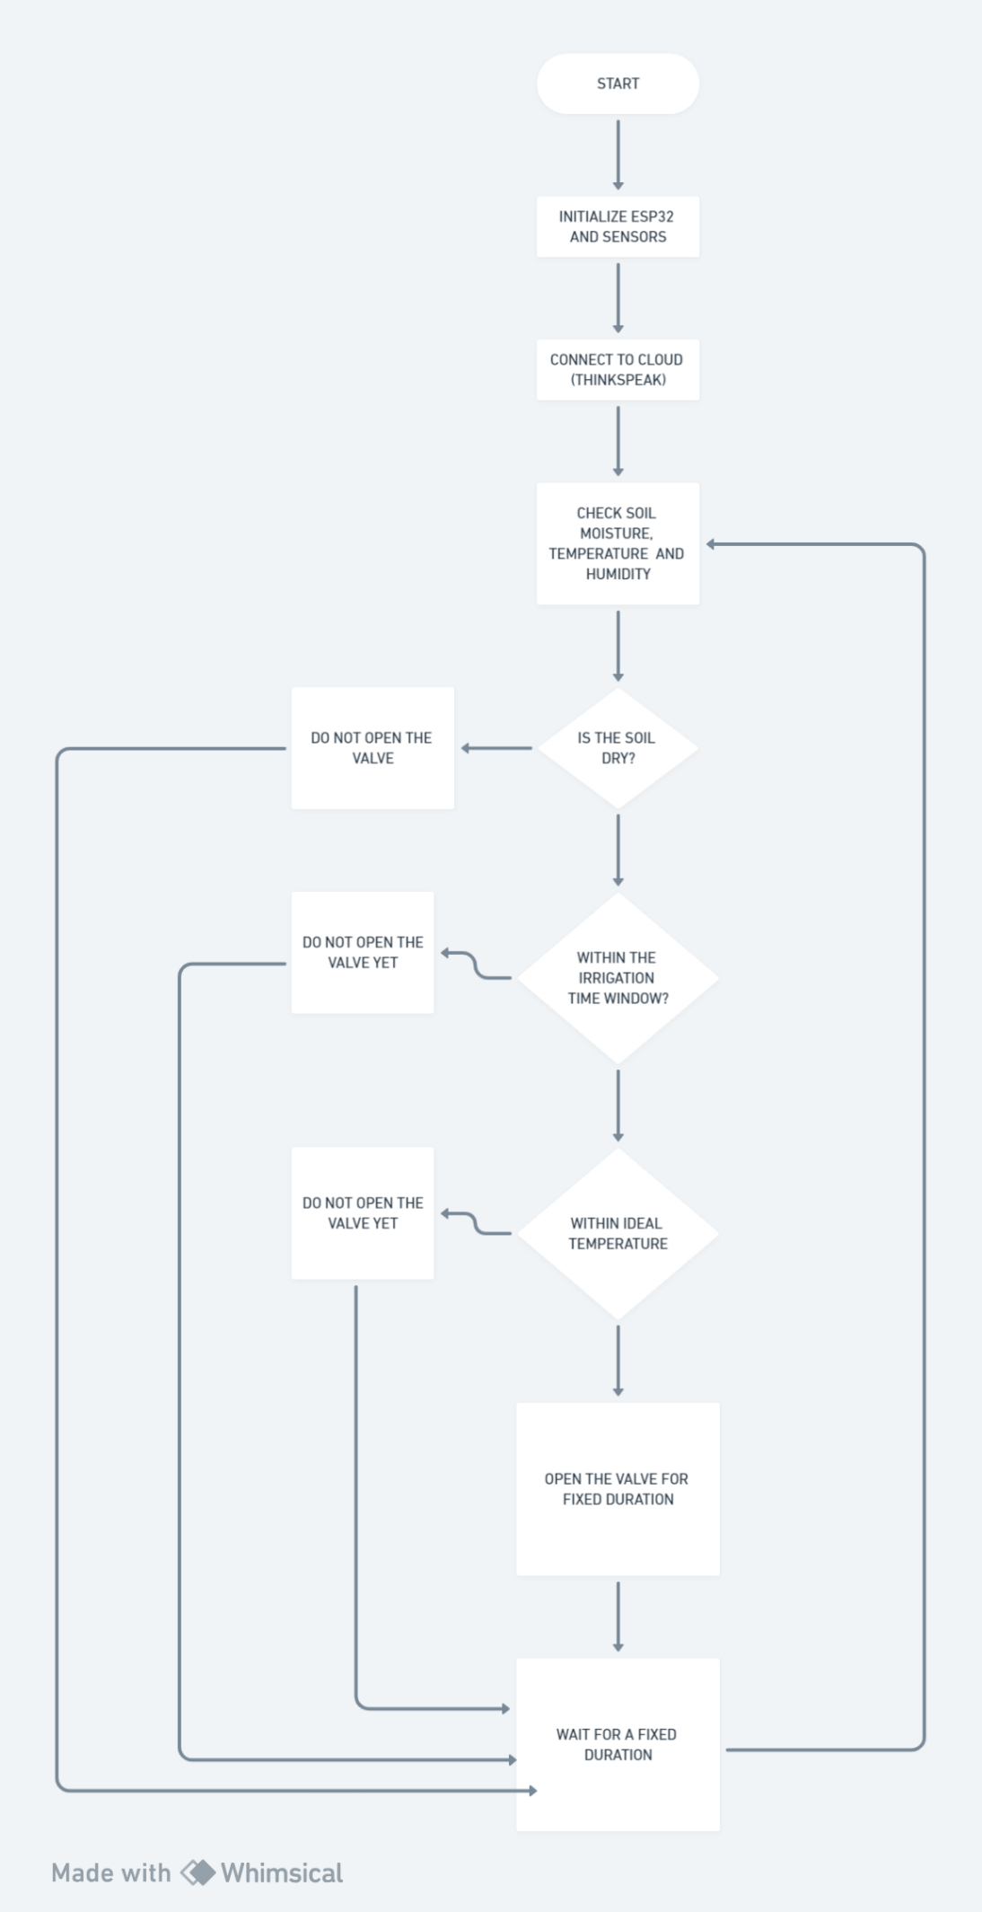

**SENSORS:**

1. Moisture Sensor - SEN0308 DFRobot
2. Temperature Sensor—DS18B20
3. Air Humidity Sensor—DHT22
4. Water Flow Sensor—FS300A
5. Solenoid Valve—Hunter PGV
6. Relay
7. Step down voltage regulator to supply the ESP32 with the 5 V needed for operation

**SOIL NUTRIENT MONITORING:**

**NPK sensor** can be used to measure the Nitrogen, Phosphorous and Potassium values from the soil.

**FLOW**

